**CHAPTER 7**

**PERFORMANCE ANALYSIS**

**7.1 Testing**

In machine learning, we often use the classification models to get a predicted result of population data. Classification which is one of the two sections of supervised learning, deals with data from different categories. The training dataset trains the model to predict the unknown labels of population data. There are multiple algorithms, namely, Logistic regression, K-nearest neighbour, Decision tree, Naive Bayes and Neural networks etc. All these algorithms have their own style of execution and different techniques of prediction. But, at the end, we need to find the effectiveness of an algorithm. To find the most suitable algorithm for a particular business problem, there are few model evaluation techniques. In this final phase, we will test our classification model on our prepared image dataset and also measure the performance on our dataset. To evaluate the performance of our created classification and make it comparable to current approaches, we use accuracy to measure the effectiveness of classifiers. After model building, knowing the power of model prediction on a new instance, is very important issue. Once a predictive model is developed using the historical data, one would be curious as to how the model will perform on the data that it has not seen during the model building process. One might even try multiple model types for the same prediction problem, and then, would like to know which model is the one to use for the real-world decision making situation, simply by comparing them on their prediction performance (e.g., accuracy). To measure the performance of a predictor, there are commonly used performance metrics, such as accuracy, recall etc. First, the most commonly used performance metrics will be described, and then some famous estimation methodologies are explained and compared to each other. "Performance Metrics for Predictive Modelling In classification problems, the primary source of performance measurements is a coincidence matrix (classification matrix or a contingency table)”. Above figure shows a coincidence matrix for a two-class classification problem.

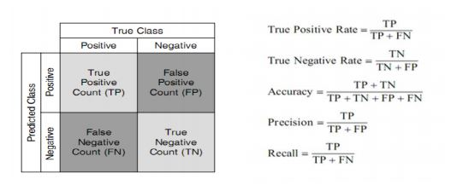

Figure 7.1: Confusion Matrix and Formulae

As being seen in above figure, the numbers along the diagonal from upper-left to lower-right represent the correct decisions made, and the numbers outside this diagonal represent the errors. "The true positive rate (also called hit rate or recall) of a classifier is estimated by dividing the correctly classified positives (the true positive count) by the total positive count. The false positive rate (also called a false alarm rate) of the classifier is estimated by dividing the incorrectly classified negatives (the false negative count) by the total negatives. The overall accuracy of a classifier is estimated by dividing the total correctly classified positives and negatives by the total number of samples.

**7.2 Results**

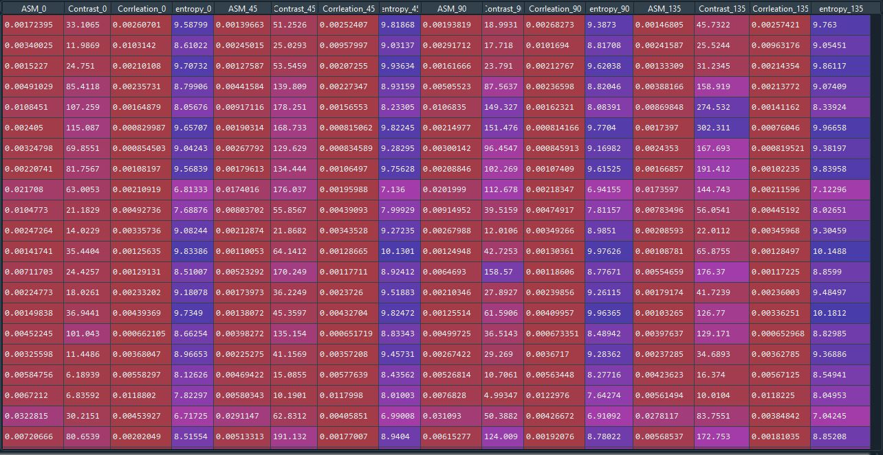

Figure 7.2: Sample Dataset

A total of 2000 image samples are used for training and testing the SVM model as data sets. The training and test dataset are divided into 80% and 20% of the total image dataset respectively.

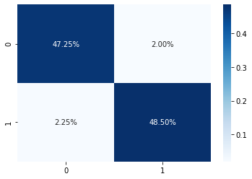

Figure 7.3: Confusion Matrix

After the model evaluation process the model showed a promising accuracy of 95.75% therefore the trained model was saved as a pickle file and a separate module was implemented to check the classification result of the model wherein the user has to input a query image of a pipe and the classification label was obtained for the query image.